CHAPTER 4: Ecosystems
Worksheet 4.5

Food chains and food webs
Science Quest 7: pages 122–127
Answers

Food chains
1. An estuary is where a river meets the sea. Estuaries often contain shallow salty water in which a water grass called eel grass grows. The larva of small animals called copepods use the grass as a food source. Eels are predators of copepods and the eels are the prey of adult herring fish.
(a) Use this information to complete the food chain.

In this food chain, identify the:
Copepod larva
(b) herbivore
Eel
(c) second order consumer
Eel grass
(d) producer.

Food webs
2. (a) Use the following information to construct a food web.
Frogs are eaten by snakes.  Wombats eat grass.  Magpies eat grasshoppers.  Grass is eaten by caterpillars.  Kookaburras prey on snakes.  Frogs prey on grasshoppers.  Grasshoppers eat grass.  Snakes prey on magpies.  Frogs eat caterpillars. | 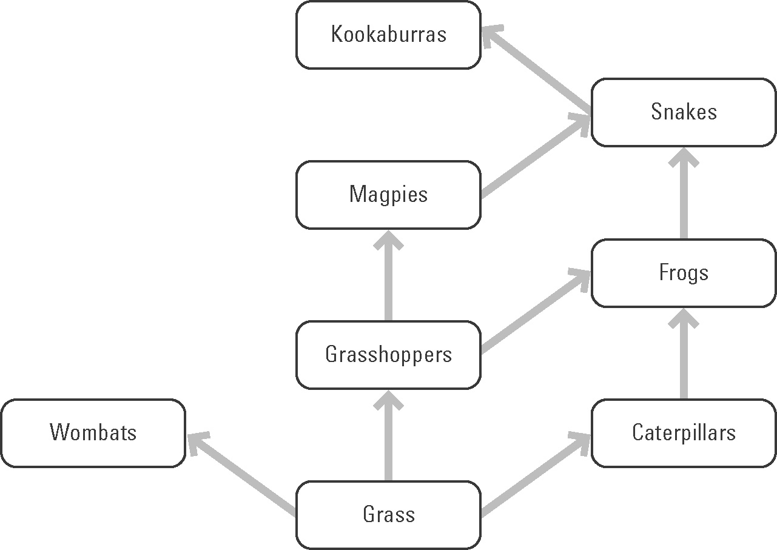
Snakes
(b) Identify the third-order consumer(s).
4
(c) Calculate the number of carnivores in this food web.
(d) Explain how decomposers fit into this food web.
Decomposers break down the dead remains of these organisms and recycle nutrients back to the environment.

